# Assignment 1

a.

1. There are n identical trails. This is satisfied, since each observation was recorded at the same town, same intersection, within one-half an hour time range.
2. There are 2 possible outcomes. This is satisfied, because the car is either alternative fuel using or not.
3. Each trail is independent to others. This condition is satisfied, because the type of one car does not affect the type of next car being observed.
4. The possibility of success remains constant through trails. This condition holds, because this is not likely to be affected by excluded measures.
5. The random variable of interest W is number of success. Satisfied, in this experiment , W=14.

b.

Wald: 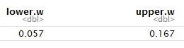

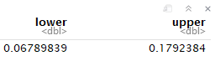Wilson:

Agresti-Coull:

c.

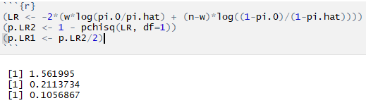 By performing 2-side Likelihood Ratio test for H0: π = 0.08 and Ha: π ≠ 0.08, with α = 0.05.

We see the p-value for the test is large, so we fail to reject H0.

Therefore, we cannot say the probability of alternative fuel use in this intersection is different from the nationwide probability.

2. Wald

95% of all similarly constructed confidence intervals will contain the true parameter π.

1. 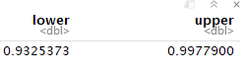Wilson

We expect 95% of all similarly constructed confidence intervals to contain the true parameter π.

1. We can test this by performing Score test with H0: π = 1, Ha: π < 1, α = 0.05.

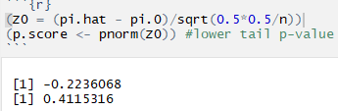

We fail to reject H0.

So, it is possible for π = 1.